
KUVEMPU UNIVERSITY

Department of P.G.studies and research in MCA and Computer Science Jnana Sahyadri, Shankaraghatta – 577451
Shivamogga District,Karnataka

A PROJECT REPORT ON
“Object detection for blind people”
Submitted in partial fulfillment of the requirements for the award of the Degree of

“MASTER OF COMPUTER SCIENCE
Submitted by
ABHINANDAN M K
P06MC23S038028
Under the guidance of
Dr.RAVIKUMAR .M.
Professor
Department of P.G Studies and Research in MCA and ComputerScience Kuvempu University, Jnana Sahyadri
Shankaraghatta-577451

2024–25


KUVEMPU UNIVERSITY
Department of P.G.studies and research in MCA and ComputerScience Jnana Sahyadri, Shankaraghatta – 577451
ShivamoggaDistrict,Karnataka
CERTIFICATE
This is to certify that the project entitled “Object detection for blind people” submitted by Mr. ABHINANDAN M K (P06MC23S038028) student of M.Sc course under the guidance of Dr. RAVIKUMAR .M. Professor, Department of MCA and Computer Science ,for the partial fulfillment of the requirements for the completion of the Degree, MASTER OF COMPUTER SCIENCE, prescribed by the Kuvempu University during the academic year 2024-2025.
Chairman: Under the Guidance
…………………. ………………….
Dr.PRABHAKAR.C.J Dr.RAVIKUMAR .M.
Department of MCA and Computer Science Professor
Department of MCA and
Computer Science

Date: Signature of the Examiners
Place:Shankaraghatta
1.………………………
2……………………….

ACKNOWLEDGEMENT
On presenting the project report on “Object detection for blind people” I feel great to express my humble feelings of thanks to all those who have helped me directly or indirectly in the successful presentation of the project.
I would like to thank my beloved guide Dr. M RAVIKUMAR, Professor, Department Of MCA & Computer Science, who helped me a lot in presenting this project, for his continuous encouragement and guidance throughout the presentation.
I extend my sincere thanks to Dr.PRABHAKAR.C.J,professor and chairman, and Dr. YOGISH NAIK G.R, and Dr. SURESHA M Associate Professor , Kuvempu University, Shankaraghatta, for guidance, constant encouragement and valuable suggestion throughout the project.
We would like to thanks my parents for their faith and confidencere posedonus to right path. And also, we thank all my friends who co-operated with us to best possible extent.
Finally, I would like to thank the whole Teaching and Non-Teaching Staff of M.Sc. Computer Science.
Mr.ABHINANDAN M K

ABSTRACT
REAL-TIME OBJECT DETECTION FOR BLIND PEOPLE represents a major advancement in accessibility technology, combining computer vision with regional language support to enhance usability. This system uses advanced object detection algorithms to analyze live video streams, identify surrounding objects, and visually mark them with bounding boxes and labels. In addition to visual tagging, the system provides auditory feedback in the Kannada language, now delivered in the developer’s own voice, ensuring better comprehension and familiarity for native speakers.
This project explores the development, implementation, and real-world implications of such a system tailored for the visually impaired. It aims to enhance situational awareness, improve safe navigation, and promote independence in everyday activities by enabling users to understand their surroundings through sound and sight-based cues.
By integrating Kannada audio output in a familiar voice along with labeled bounding box visuals, the system addresses both linguistic and perceptual barriers. This approach opens up new opportunities for inclusive innovation, providing a more intuitive and culturally relevant user experience.
Ultimately, this real-time object detection system offers a transformative solution for empowering blind individuals, helping them interact more confidently and autonomously in diverse environments, and fostering a more inclusive society.

Content Table

Chapter 1:Introduction ................................................. 1-6
1.1 Overview
1.2 Objective
1.3 Challenges
1.4 Applications
1.5 Advantages
1.6 Disadvantages
Chapter 2: Literature Survey ...................................7-11
Chapter 3: Methodology .......................................... 12-18
3.1 Python
3.2 Open CV
3.3 YOLO Algorithm
3.4 NumPy
3.5 gtts (Text to Speech)
3.6 Visual Studio
3.7 Architecture
3.8 Data Flow Diagram
Chapter 4: Implementation ...................................... 19-24

4.1 Overview of Implementation

4.2 YOLOv3 Architecture and Working
4.3 Model Loading and Object Recognition Workflow
4.4 Object Detection and Audio Feedback Workflow
4.5 System Interaction and Real-Time Processing
4.6 Summary of Implementation
Chapter 5: Test Cases ............................................... 25-26
Chapter 6: Results ..................................................... 27-30
Conclusion .................................................................. 31
Bibliography ............................................................... 32

CHAPTER 1
INTRODUCTION
The Real-Time Vision Assist project aims to create software that helps individuals with visual impairments by identifying and labeling items in their immediate environment. Utilizing deep learning algorithms, the system provides real-time feedback through audio, empowering users to move around their surroundings with greater independence and safety.
Living a regular life while being blind is complex and challenging—tasks such as recognizing objects and ensuring safety become difficult. This project, Real-Time Vision Assist, uses machine learning to capture the user’s environment and convey meaningful information to assist visually impaired individuals.
The system uses advanced object-detection techniques to identify what’s around the user and delivers the results through audio prompts. This technology falls within the accessibility and innovation category—it’s one of those innovations designed to narrow the gap between disability and independence.
The goal of this project is to create a vision-assist system that helps blind persons by providing voice prompts about nearby objects and obstacles. The software aims to enhance spatial awareness, enabling safer and more autonomous movement.
The system will incorporate a video camera to receive real-time video feed from the user’s surroundings. It will process the video to detect and recognize objects. Detected objects will be labeled, and their names will be converted into audio cues delivered to the user via headphones or speakers.
1.1.OVERVIEW
A real-time assistive object-detection system employs a YOLO (You Only Look Once) model—typically YOLOv3, YOLOv5, or YOLOv8—integrated with a wearable camera or smartphone to aid visually impaired individuals in navigation. As the device captures live video, YOLO processes each frame end-to-end to detect obstacles such as pedestrians, stairs, curbs, traffic signs, everyday objects, or small indoor items. Detected objects are converted into spoken feedback via text-to-speech outputs like TTS or pyttsx3, announcing both the type and relative position (“person ahead,” “chair on left”). Some systems also integrate haptic feedback—like discrete vibratory alerts—to reinforce spatial alerts. Academic and community-driven implementations have reported detection accuracies between 85–95 % for YOLOv3 on common classes, with navigation-specific models such as the EchoPath smart cane and custom versions of YOLOv8 demonstrating precision and usability in real-world settings
1.2.OBJECTIVE
The objective of this proposed project is to develop software using Python designed to identify objects within frames using the YOLO algorithm. The identification of an element will solely be determined by the trained dataset.
The goal is to train and optimize models that can recognize objects in real-time from live video streams collected by cameras. The aim is to increase the accuracy and dependability of object recognition algorithms by using modern machine learning methods. Proper algorithms and structures will be employed in order to achieve real-time processing of live video streams on the system, along with timely feedback provided to the user.
- Object Identification: Understanding and naming of familiar objects (e.g., cup, chair), thereby reducing dependence on optical vision to identify objects necessary for daily activities.
- Enhance Mobility and Independence: Improve transport and movement. Discover and design an application that can achieve accurate movement recognition and frequent identification of objects in different environments (interior and exterior) in real time, to give quick responses to users.
- Improve Situational Awareness: Improve object recognition technology that can detect nearby objects and enhance the user’s awareness of their surroundings.
- Provide Intuitive and Accessible Feedback: Feedback should be simple and easy to understand. Incorporate sound signals to help announce the names of detected objects in simple words and terms for the user to understand.
- Maintain High Accuracy and Reliability: Develop robust architectures that enable the software to run in various settings while providing consistent and high-standard performance.
1.3.CHALLENGES
- Processing Delays:
The computations involved in the process are intensive due to the sophisticated algorithms used. Delays in latency time make achieving real-time feedback a challenge.
- Hardware Limitations:
Devices with limited physical construction, lower processing power, and insufficient memory impose restrictions on software performance and development.
- Internet Requirement:
Some systems rely on cloud-based processing, which demands a stable internet connection. This becomes a limitation in areas with poor connectivity, especially where access to healthcare and other essential services is limited.
- Feedback Mechanisms:
Previously existing systems often rely only on haptic feedback, which can be difficult for users to interpret when recognizing detected objects.
1.4.APPLICATIONS

1.4.1.Autonomous Transportation & Traffic
- Self-Driving Vehicles (ADAS & Autonomous Cars):
Object detection enables real-time recognition of vehicles, pedestrians, cyclists, traffic signs, road boundaries, and obstacles—crucial for lane-keeping, collision avoidance, and safe.
- Pedestrian Crash Avoidance Mitigation (PCAM):
Vehicle systems detect pedestrians and cyclists to issue alerts or apply emergency braking; integrated into many modern cars like Volvo, Mercedes, and Lexus
- Smart City Traffic Monitoring:
Used in city cameras to count vehicles, monitor traffic flow, analyze congestion, and control signals intelligently

1.4.2.Retail, E-Commerce & Inventory Management
- Shelf Monitoring & Inventory Analytics:
Smart cameras detect out-of-stock items, track product interactions, and enable restocking alerts in real time.
- Automated Checkout & Visual Search:
Systems like Amazon Go combine object detection with checkout automation, while visual search features allow customers to search by uploading product images
- Brand & Logo Detection, Counterfeit Monitoring:
Detecting logos and brand placement helps track brand visibility, monitor unauthorized listings, and enforce IP protection

1.4.3.Healthcare & Medical Imaging
- Diagnostic Imaging:
AI-assisted detection highlights tumors, fractures, infections, or anomalies in X-rays, CTs, and MRIs, accelerating diagnostics and aiding radiologists
- Remote Monitoring & Predictive Maintenance of Care:
Video feeds from medical settings can detect patient movement, falls, or signs of decline in real time

1.4.4.Security, Surveillance & Smart Cities
- Threat Detection & Behavior Analysis:
Security cameras detect prohibited items (such as weapons), unusual behavior, unattended baggage, or intrusions automatically.
- Crowd Management & Demographics:
Used to monitor crowd sizes, identify demographic patterns, and assess flow in public places during large events or transit hubs
- Maritime Collision Avoidance (MCAS):
Object detection combined with thermal imaging identifies floating hazards and vessels not broadcasting AIS, enhancing safety at sea (e.g. Sea.AI)
1.5.ADVANTAGES
1.5.1.Real-Time Processing & Responsiveness
Object detection enables real-time analysis of images and video—crucial for applications like self-driving cars, automated traffic signaling, and robotics. It can instantly identify and track moving objects, allowing systems to react swiftly and intelligently.
1.5. 2. Improved Accuracy & Reliability
Modern object detection algorithms (YOLO, SSD, R-CNN, etc.) deliver high precision with bounding boxes and class predictions. This minimizes false positives and enhances the reliability of systems across domains like safety surveillance, inventory control, and medical imaging
1.5.3. Automated Workflows & Labor Savings
By automating mundane tasks—such as shelf monitoring, defect detection, or hazard recognition—object detection reduces manual inspection and frees up human labor for strategic work. This boosts productivity and operational efficiency.
1.5.4. Data-Driven Decision Making
In domains like retail, logistics, and industry, real-time object detection generates actionable insights: restocking alerts, demand trends, or operational anomalies. These insights power smarter, data-backed decisions
1.5.5. Enhanced Safety & Risk Reduction
Critical safety applications—such as pedestrian detection in vehicles, alert systems in manufacturing, or hazard detection in public spaces—are powered by object detection to prevent accidents and reduce danger.

1.6.DISADVANTAGES
- Processing Delays:
The algorithms used are sophisticated and computationally intensive, which leads to significant processing delays. As a result, achieving real-time feedback remains a major challenge.
- Hardware Limitations:
Devices with limited processing power, small memory, or poor construction physically restrict the ability to run complex object detection systems efficiently.
- Internet Requirement:
Some systems rely on cloud-based processing and therefore require a stable internet connection. This dependency poses significant limitations in regions with poor connectivity or limited access to healthcare infrastructure
- Feedback Mechanisms:
Previous systems often only support basic haptic (touch-based) feedback, which can make it difficult for users to accurately recognize what has been detected.

Chapter 2
Literature Survey
- The PASCAL Visual Object Classes (VOC) Challenge

The PASCAL Visual Object Classes (VOC) Challenge is one of the most influential benchmarks in the field of computer vision. It was introduced to facilitate standardized evaluation of object detection and recognition algorithms across a wide range of object categories. The challenge provided annotated datasets consisting of images from realistic scenes containing objects like people, animals, vehicles, and everyday items. It focused on four main tasks: classification, detection, segmentation, and person layout estimation. One of its major contributions was the introduction of consistent performance metrics, such as precision-recall curves and mean Average Precision (mAP), which became widely adopted in later benchmarks like COCO and ImageNet. The VOC datasets (2007 and 2012 editions, in particular) were extensively used in training and testing deep learning models like YOLO, SSD, and Faster R-CNN. The VOC challenge significantly accelerated progress in object recognition research by encouraging reproducibility, collaboration, and open evaluation protocols in the computer vision community. Its legacy continues to shape the way modern models are trained and evaluated.

- DSSD: Deconvolutional Single Shot Detector
The Deconvolutional Single Shot Detector (DSSD) was proposed to improve the accuracy of the original Single Shot Multibox Detector (SSD) by incorporating deconvolutional layers for better object localization and feature enhancement. While SSD is known for its speed and real-time performance, it struggles with detecting small objects due to the lack of context information from deeper layers. To address this limitation, DSSD adds a deconvolution module on top of SSD, which upsamples high-level features and combines them with lower-level spatial information through skip connections. This fusion enhances semantic richness without compromising localization accuracy. Additionally, the ResNet-101 backbone is used in DSSD instead of VGG-16 to improve feature extraction. The results showed that DSSD achieved higher accuracy than SSD, especially on datasets like PASCAL VOC and MS COCO, while maintaining a reasonable trade-off between speed and precision. This architecture paved the way for future object detectors that balance computational efficiency with improved contextual understanding for small object detection.

- IQA: Visual Question Answering in Interactive Environments
The paper IQA: Visual Question Answering in Interactive Environments introduces a novel benchmark and methodology for integrating visual perception with reasoning and interaction. Traditional Visual Question Answering (VQA) models operate on static images and are limited in their ability to explore or manipulate the environment to seek relevant information. To overcome this, the authors propose IQA (Interactive Question Answering), a framework where an embodied agent must navigate a 3D environment to gather visual evidence and answer questions. The dataset used is based on AI2-THOR, a photorealistic simulation environment featuring indoor scenes such as kitchens, bedrooms, and living rooms. The agent is trained to perceive the environment, understand natural language questions, and determine actions such as moving, turning, or opening objects to find answers. The study combines reinforcement learning with deep visual and language understanding, demonstrating a significant step forward in creating intelligent agents capable of perception-driven reasoning in dynamic, real-world scenarios. This work lays a foundation for future VQA systems that are not just passive observers but active participants in the environment.

- Deep Residual Learning for Image Recognition
The paper Deep Residual Learning for Image Recognition introduced the groundbreaking ResNet (Residual Network) architecture, which significantly advanced the performance of deep convolutional neural networks (CNNs) for image classification tasks. The key innovation of ResNet lies in its use of residual learning—where shortcut connections (also known as skip connections) are added to allow gradients to flow more effectively during backpropagation. This approach addresses the degradation problem in deep networks, where adding more layers leads to higher training error. By learning residual mappings instead of direct mappings, ResNet enables the successful training of ultra-deep networks with over 100 layers. The proposed architecture won the ImageNet Large Scale Visual Recognition Challenge (ILSVRC) 2015, achieving a top-5 error rate of 3.57%, outperforming all previous models. ResNet has since become a fundamental backbone in numerous computer vision applications, including object detection (e.g., Faster R-CNN, YOLOv3-Darknet53), segmentation, and medical imaging. The introduction of residual blocks marked a paradigm shift in network design and has influenced nearly all subsequent deep learning architectures.
- Speed/Accuracy Trade-Offs for Modern Convolutional Object Detectors
In their influential paper Speed/Accuracy Trade-Offs for Modern Convolutional Object Detectors, Huang et al. conduct a comprehensive evaluation of state-of-the-art object detection models to analyze the trade-offs between detection accuracy and inference speed. The study benchmarks multiple popular architectures—including Faster R-CNN, R-FCN, SSD, and YOLO—on the COCO dataset using a unified framework built on TensorFlow’s Object Detection API. By varying backbone networks such as ResNet, Inception, and MobileNet, the authors assess the impact of model depth and complexity on performance. Their analysis shows that while two-stage detectors (like Faster R-CNN) offer higher accuracy, single-stage detectors (like SSD and YOLO) provide significantly faster inference, making them suitable for real-time applications. The paper also introduces a modular and extensible detection framework that enables researchers to easily replicate and extend the experiments. This work serves as a vital reference for practitioners and researchers in selecting the right detection model depending on the specific requirements of speed vs. accuracy in real-world applications like autonomous driving, surveillance, and mobile vision systems.
- Rich Feature Hierarchies for Accurate Object Detection and Semantic Segmentation
The paper Rich Feature Hierarchies for Accurate Object Detection and Semantic Segmentation by Girshick et al. marks a pivotal moment in computer vision with the introduction of the R-CNN (Regions with Convolutional Neural Networks) framework. This work bridged the gap between deep learning and traditional object detection by integrating convolutional neural networks (CNNs) with region proposal methods. The R-CNN approach first generates region proposals using selective search, then extracts CNN features for each region, and finally classifies them using SVMs. The method significantly outperformed previous techniques on benchmarks like PASCAL VOC in both object detection and semantic segmentation tasks. The key contribution of this paper was demonstrating that deep learning could drastically improve accuracy in object detection when combined with region-based strategies. Although computationally expensive, R-CNN laid the foundation for subsequent faster models such as Fast R-CNN, Faster R-CNN, and Mask R-CNN. This work has had a long-standing impact on object detection pipelines and continues to influence research in both academia and industry.

- Simple Convolutional Neural Network on Image Classification
In their paper Simple Convolutional Neural Network on Image Classification, Dong et al. present a lightweight and straightforward convolutional neural network (CNN) architecture designed specifically for image classification tasks. Unlike more complex models such as VGGNet or ResNet, this CNN focuses on reducing computational complexity while maintaining competitive accuracy, making it suitable for real-time applications and environments with limited processing power. The authors discuss key components of the architecture, including the number of convolutional and pooling layers, activation functions, and optimization techniques like stochastic gradient descent. The model was evaluated on popular image datasets and demonstrated satisfactory performance with faster training and lower resource consumption. This study is especially valuable for practitioners looking to deploy deep learning models on edge devices, embedded systems, or in applications where speed and simplicity are critical. The authors conclude that even simple CNN models can be effectively optimized to yield robust classification results, thereby making deep learning more accessible and deployable in practical scenarios.

- Faster R-CNN: Towards Real-Time Object Detection with Region Proposal Networks
The paper Faster R-CNN: Towards Real-Time Object Detection with Region Proposal Networks by Ren et al. introduces a groundbreaking improvement in the field of object detection by integrating the region proposal generation process directly into the convolutional neural network pipeline. This method builds upon the earlier R-CNN and Fast R-CNN architectures by replacing external region proposal methods like selective search with a novel Region Proposal Network (RPN) that shares convolutional features with the detection network. This innovation drastically reduces the computational cost and increases the speed of the object detection process, achieving near real-time performance without sacrificing accuracy.
Faster R-CNN uses a unified, end-to-end architecture in which the RPN generates object proposals that are then classified and refined by the Fast R-CNN module. This model was trained and evaluated on benchmark datasets such as PASCAL VOC and MS COCO, showing state-of-the-art results in terms of both mean average precision (mAP) and inference time. The paper not only advanced object detection capabilities but also laid the foundation for further innovations like Mask R-CNN. It remains one of the most influential works in deep learning-based computer vision

CHAPTER 3
METHODOLOGY

3.1 Python

It is the versatile coding language, popular among developers due to its readability and ease of use. Hence, it is a high-level, interpreted programming dialect. Its design philosophy reflects code consistency and simplicity, making it suitable for both business-to-business and business-to-consumer models. The sources of training are apprentices and experienced software engineers. In fact, Python supports a variety of programming standards, including three major paradigms of programming: procedural, object-oriented, and functional.

Characteristics of Python:
- Readability and Simplicity: Python's syntax is purposely aimed at readability, making it suitable for both amateur and professional programmers.
- Dynamically Typed: These types are defined during runtime, offering flexibility, but can cause issues if not handled well during runtime.
- Interpreted Language: As an interpreted language, Python processes code line-by-line, which helps significantly in debugging.
- Extensive Standard Library: The standard Python library includes packages for handling files, system operations, and data manipulation.
- Large Ecosystem: A wide variety of libraries are available, such as NumPy for numerical computing, Pandas for data analysis, Flask and Django for web development, TensorFlow and OpenCV for machine learning and computer vision respectively.
- Cross-Platform: Python can run on multiple operating systems such as macOS, Windows, and Linux.

Python in Machine Learning Models
Python is one of the most sought-after programming languages for implementing machine learning models due to its comprehensive capabilities and active community support. Whether working on simple tasks or complex deep learning models, Python provides the tools and frameworks needed.

Practical Application Steps:
- Data Collection: Gathering data from sources like CSV files, databases, or web scraping.
- Data Preprocessing: Preparing and refining data to ensure it's suitable for analysis. This includes handling missing values, normalization, and feature extraction.
- Model Selection: Choosing the appropriate ML algorithm (classification, regression, clustering, etc.).
- Model Training: Feeding the data into the selected algorithm to train the model.
- Model Evaluation: Assessing model performance using metrics like recall, precision, F1-score, etc.
- Model Deployment: Integrating the model into an environment where it can make real-time predictions.

3.2 OpenCV
OpenCV (Open Source Computer Vision Library) is an open-source library developed to simplify computer vision tasks through a collection of compiled libraries. Originally developed by Intel, it has become a standard toolkit for image and video analysis. OpenCV is known for its flexibility and efficiency in handling tasks from simple image transformations to complex machine learning operations. It supports various features such as motion detection, object tracking, and video stabilization.

Features of OpenCV:
- Comprehensive Tools: Offers a broad set of tools for image manipulation, video analysis, and deep learning integration.
- Cross-Platform: Compatible with Linux, Windows, iOS, and macOS.
- Multi-Language Support: Works with Python, C++, Java, and MATLAB.
- Performance Optimization: Includes hardware acceleration, optimized algorithms, and multi-threading support.
- Extensibility: Allows adding new data types, algorithms, and functions.
OpenCV supports sophisticated use cases like augmented reality, robotics, and surveillance, where accurate and real-time visual data processing is critical.

3.3 YOLO Algorithm
YOLO (You Only Look Once) is a real-time object detection system known for its speed and accuracy. YOLO predicts bounding boxes and class probabilities simultaneously, making it highly efficient.

Features:
- Real-Time Detection: Processes images in real time, ideal for live video streams.
- Single Shot Detection: Unlike other methods, YOLO processes the entire image once, predicting multiple objects in one pass.
- High Accuracy: Maintains strong accuracy across diverse object classes.
- Unified Architecture: Simplifies the training and deployment process.

YOLO Methodology:
- Single Pass Detection: A single neural network processes the full image by dividing it into grids.
- Bounding Box Prediction: Each grid cell predicts multiple bounding boxes and their center coordinates, width, height, and confidence scores.
- Class Prediction: Predicts the probability of each object class using softmax activation.
- Feature Extraction: Based on CNN, allows predictions at multiple image scales.
- Non-Maximum Suppression (NMS): Keeps the best bounding box by removing duplicates based on confidence score.
- Training: Trained end-to-end on labeled datasets using loss function minimization (e.g., SGD).
- Post-processing: Removes boxes below a confidence threshold, applies NMS, and outputs final bounding boxes and classes.

3.4 NumPy
NumPy (Numerical Python) is a core package for numerical computing in Python. It supports arrays, matrices, and mathematical functions required for data analysis, simulation, and optimization.

Features:
- Mathematical Functions: Offers a broad range of functions including trigonometric, statistical, and algebraic operations.
- Broadcasting: Handles operations between arrays of different shapes without needing loops.
- Linear Algebra Support: Built-in support for matrix operations, inverses, eigenvalues, etc.
- Random Number Generation: Provides functions for simulations and probabilistic models.
- Integration with Other Libraries: Works seamlessly with Pandas, SciPy, Matplotlib, etc.

3.5 gTTS (Google Text-to-Speech)
gTTS is a Python library and interface to Google Text-to-Speech API, which converts text into speech using Google's online services. It supports multiple languages and produces natural-sounding audio output.

Features:
- Multilingual Support: Supports a wide range of languages including Kannada, Hindi, English, Tamil, and more, making it suitable for regional and international applications.
- Natural Sounding Voice: Uses Google’s cloud-based speech engine, which produces highly realistic and clear speech output.
- Simple Integration: Easy to use with minimal code for converting text to .mp3 audio files.
- Language & Accent Control: Allows selection of different accents or dialects for supported languages (e.g., en-uk, en-us).
- Cross-Platform Output: Works on all major platforms (Windows, Linux, macOS) as long as there’s internet access.
- Small File Output: Generates compact .mp3 files that are easy to play and transfer.
- Custom Script Support: Can be used in custom scripts and integrated with other applications like real-time object detection.

3.6 Visual Studio
Visual Studio is Microsoft’s fully-featured Integrated Development Environment (IDE) used for building, testing, and deploying software. It supports multiple programming languages and integrates with tools like Git and Azure DevOps.

Key Features:
- Multi-language Support: Supports C#, C++, Python, JavaScript, and more.
- Advanced Code Editor: Includes IntelliSense, code highlighting, and refactoring tools.
- Debugging and Diagnostics: Offers powerful tools like breakpoints, call stacks, and performance profilers.
- Code Analysis and Metrics: Enforces coding standards and generates detailed reports.
- Integrated Terminal: Allows command-line operations directly from the IDE.

3.7.ARCHITECTURE
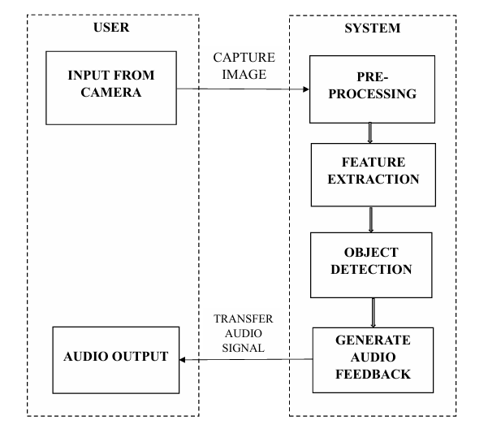
This system perspective diagram for a real-time vision assist using machine learning includes input devices are camera that captures real-time image and detect the objects, then it generates the audio signals and transfer audio feedback to users in a real time.

3.8.DATA-FLOW DIAGARAM

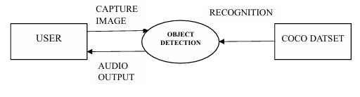
It offers outline of the system and its interaction with external entities. For the real-time vision assist using machine learning. Camera captures the real-time video stream and transfer it to the Object Detection System, where frames are grabbed and pre-processed. The pre-processed frames are then passed to the Object recognition Model, which identifies objects in the frames. the Level 0 DFD encapsulates the flow of data from the Camera to the Object Detection System, which processes this data and provides audio feedback to the user.

CHAPTER 4
IMPLEMENTATION

4.1 Overview of Implementation
This chapter describes the step-by-step implementation of the object detection system designed for visually impaired users. The system uses YOLOv3 and OpenCV to identify objects in real-time video feeds and provides audio feedback via a text-to-speech engine. Each component is modularly designed for efficient detection, voice alert generation, and user-friendly interaction.

4.2 YOLOv3 Architecture and Working

4.2.1 Introduction to YOLOv3
YOLOv3 (You Only Look Once, Version 3) is a single-stage, real-time object detection algorithm that predicts bounding boxes and class probabilities directly from full images in one evaluation.

4.2.2 Network Architecture
- Darknet-53Backbone:
A deep convolutional network with 53 layers used for feature extraction. It uses batch normalization and Leaky ReLU for better convergence and performance.
- Multi-Scale Detection:
YOLOv3 predicts objects at three different scales to improve the detection of small, medium, and large objects.
- Anchor Boxes:
Each grid cell predicts multiple bounding boxes with objectness scores, coordinates, and class probabilities.

4.2.3 How YOLOv3 Works
- Input Processing:
The input image is resized (typically to 416×416), normalized, and converted into a format suitable for the model (blob).
- Feature Extraction:
Darknet-53 extracts features at different levels to capture complex patterns.
- Feature Fusion:
Upsampled deeper feature maps are combined with shallower maps to retain both semantic and spatial information.
- Prediction Layers:
Convolutional layers generate bounding boxes and class predictions at three scales.
- Post-Processing:
Outputs are filtered by confidence threshold and refined using Non-Maximum Suppression (NMS) to remove overlapping boxes.

4.2.4 Performance Highlights
- Speed & Accuracy:
Offers a balance between speed (real-time inference) and accuracy (high mAP) even on moderate hardware.
- Strengths:
  - Works efficiently on real-time video.
  - Handles varied object sizes.
  - Adapts well to different environments.
- Limitations:
  - May struggle with dense or crowded scenes.
  - Newer models (YOLOv4, YOLOv5+) offer improvements.

4.2.5 Application in Assistive Systems
- Real-Time Object Detection:
Detects objects such as people, bags, and obstacles from a live webcam.
- Audio Feedback:
Labels detected objects using voice, aiding visually impaired users.
- Edge Deployment:
Efficient enough to run on local machines or portable systems without cloud dependence.

4.3 Model Loading and Object Recognition Workflow

4.3.1 Loading the YOLOv3 Model
- The model is integrated using OpenCV's dnn module.
- Pre-trained weights (yolov3.weights) and config file (yolov3.cfg) are loaded.
- Class labels are read from the coco.names file.

4.3.2 Identifying Output Layers
- Output layers (unconnected layers) are extracted.
- These layers return bounding boxes, confidence scores, and class probabilities during inference.

4.3.3 Preprocessing Input Frames
- Each frame is resized to 416×416.
- Pixel values are normalized (scaled to 0–1).
- Frame is converted into a blob using OpenCV

4.3.4 Performing Detection
- The blob is passed through the YOLO network.
- Raw detections are generated at multiple scales, enabling recognition of both small and large objects.

4.3.5 Mapping Class IDs to Labels
- Each prediction includes a class ID.
- The class ID is mapped to a label (e.g., "person", "chair").
- Detections below the confidence threshold are discarded.
- Non-Maximum Suppression removes duplicate bounding boxes.

4.3.6 Summary
- Model is loaded using OpenCV.
- Frames are converted to blob format.
- Multi-scale predictions are obtained.
- Class labels are mapped for object identification.
- Refined results are used for feedback.

4.4 Object Detection and Audio Feedback Workflow

4.4.1 Model Initialization
- Loads YOLOv3 model
- Loads config, weights, and labels only once for optimal performance.

4.4.2 Frame Acquisition
- Captures live video feed from webcam using:

4.4.3 Frame Preprocessing
- Each frame is resized and normalized.
- Blob is generated and passed to the model.

4.4.4 Inference and Detection
- YOLO performs detection on the blob.
- Outputs include:
  - Bounding box coordinates
  - Class IDs
  - Confidence scores

4.4.5 Post-Processing with NMS
- Apply threshold filtering (e.g., 0.5).
- Use NMS to remove overlapping boxes:

4.4.6 Audio Feedback Mechanism
- For each valid detection:
  - Draw bounding box with label on frame.
  - Convert label to voice using gTTS
- Speak each object only once per session to avoid repetition.

4.5 System Interaction and Real-Time Processing

4.5.1 Real-Time Video Stream Handling
- Frame-by-frame processing with detection overlay.
- Uses cv2.imshow() for debugging or optional visual display.

4.5.2 Audio-Only Mode for the Blind
- Visual window can be disabled.
- Only speech output remains active, making the system accessible to blind users.

4.5.3 Object Tracking and Voice Optimization
- Optionally implement object tracking to avoid repeated announcements.
- Maintain a list of spoken objects to reduce redundancy.

4.5.4 Modular Design
- Codebase is split into:
  - main.py – driver script
  - detect.py – detection logic
  - voice.py – speech synthesis
  - config.py – file paths and settings

4.6 Summary of Implementation
- YOLOv3 is used for multi-scale real-time object detection.
- OpenCV handles video feed and model inference.
- gTTS enables audio feedback for object labels.
- The system runs efficiently on standard hardware without cloud dependency.
- Designed to help blind users navigate environments with awareness of surrounding objects.

CHAPTER 5

TEST CASES

TEST  CASE ID | DESCRIPTION | EXCEPTED  OUTCOME | ACTUAL  OUTCOME | STATUS
TC01 | Starting the  OpenCV camera | Camera to be  Started | Camera started  successfully | Pass
TC02 | Basic object detection | Verify that the system is  Identifies the  Object | The system currently  identifies the  object | Pass
TC03 | Naming each object | The object is should be  Labeled | The object is labelled  successfully | Pass
TC04 | Multiple object detection | System can detect multiple objects | Multiple objects detected  successfully | Pass
TC05 | Real time Feedback | System should give audio feedback with  In a second | It provides audio feedback in less than one  second | Pass

TEST  CASEID | DESCRIPTION | EXCEPTED  OUTCOME | ACTUAL  OUTCOME | STATUS
TC06 | Various lighting conditions | Consistent  detection across lighting  conditions | It detects across lighting  conditions  successfully | Pass
TC07 | detection for moving objects. | It should detect moving objects | It detects moving objects  successfully | Pass
TC08 | Partially Occluded Objects | the system’s ability to detect partially  occluded objects. | System  identifies partially occluded objects  successfully | Pass
TC09 | System  Performance in different environments. | detection of elements  regardless of the  environment. | Successfully detection  regardless of  environment | Pass
TC10 | Audio feedback clarity | System gives clear and  understandable  audio signals. | It provides clear audio feedback | Pass

CHAPTER 6
RESULT
SCREENSHOTS
Multiple Object Detection:

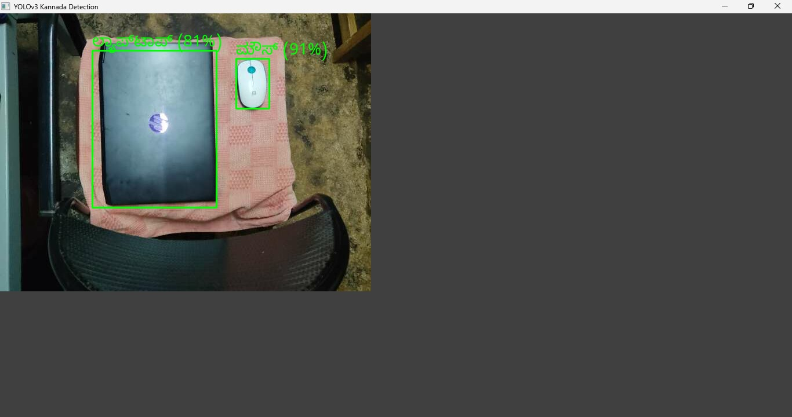
Figure.6.1.detecting multiple object
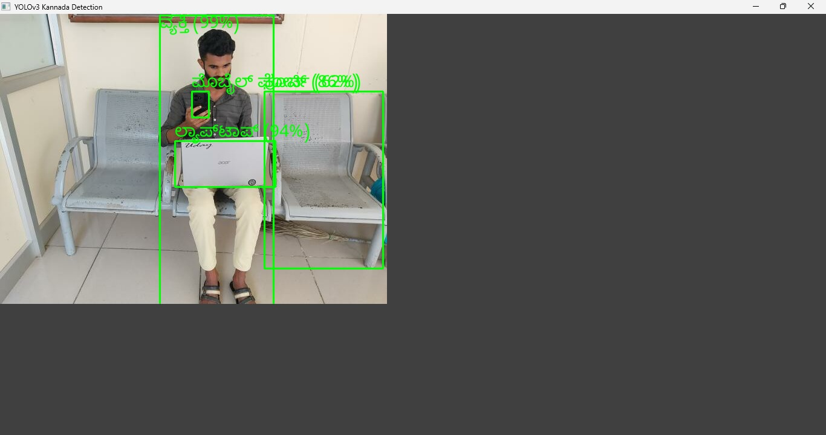
Figure.6.2.detecting multiple object

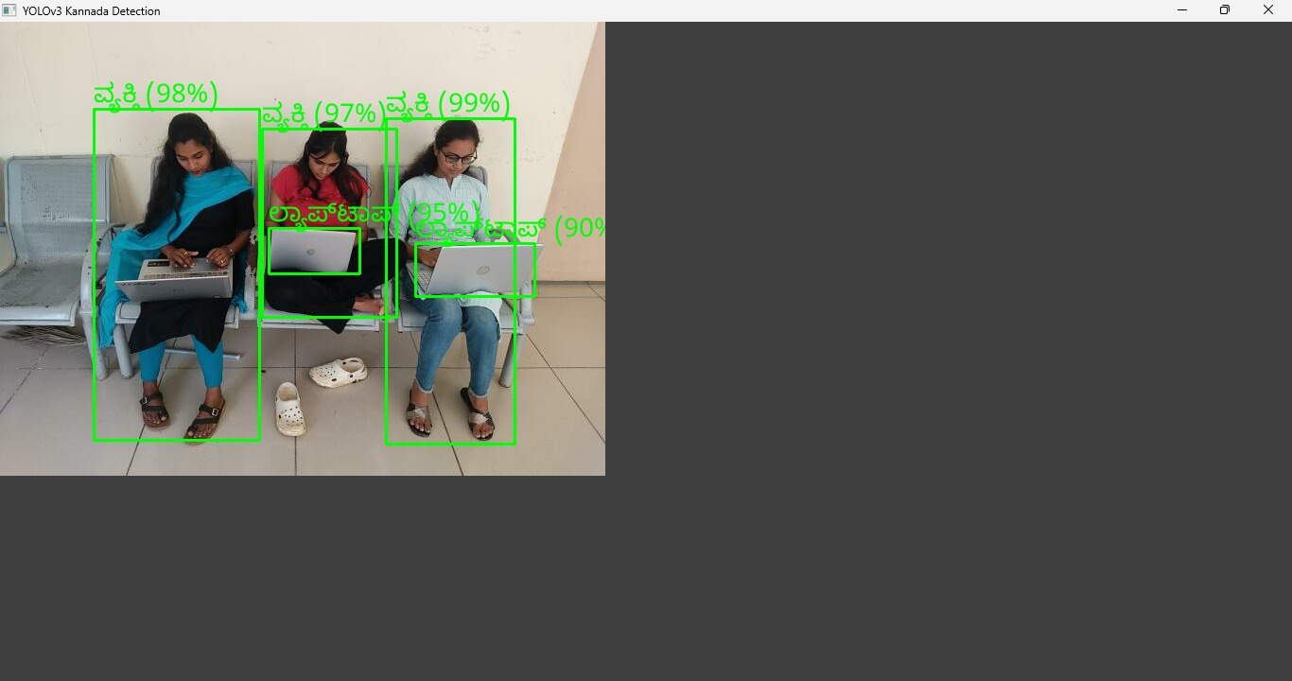
Figure.6.3.detecting multiple object

In this images it detects multiple objects with object name labelling. This will give audio feedback simultaneously for detected objects. It provides accuracy level to the each and all objects were detected.

Single Object Detection:

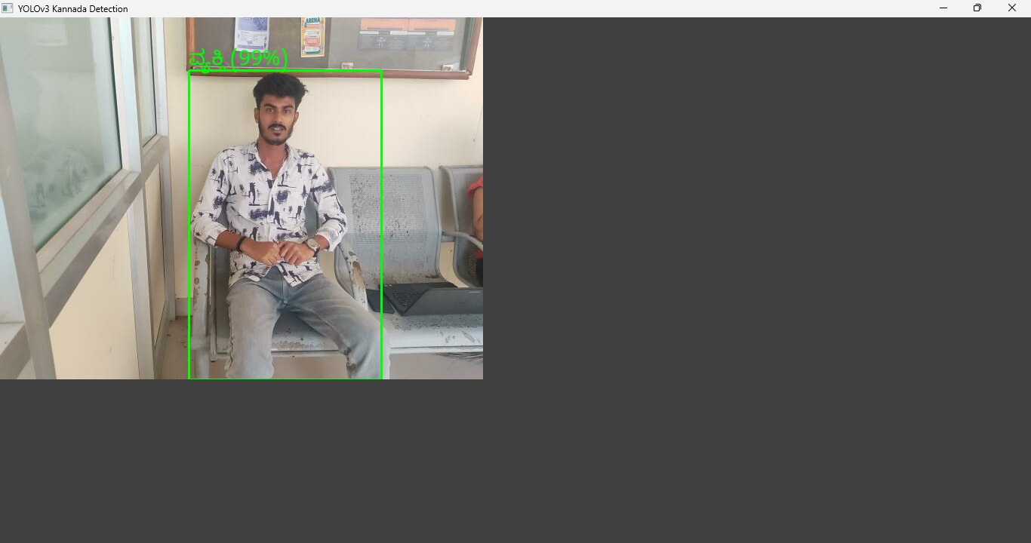
Figure.6.4.detecting single object

In this above image it detects an individual image in image with the high accuracy level of detected object and transfer the audio feedback to the visually impaired or person had low vision in a real time.

Partially Occluded Objects:
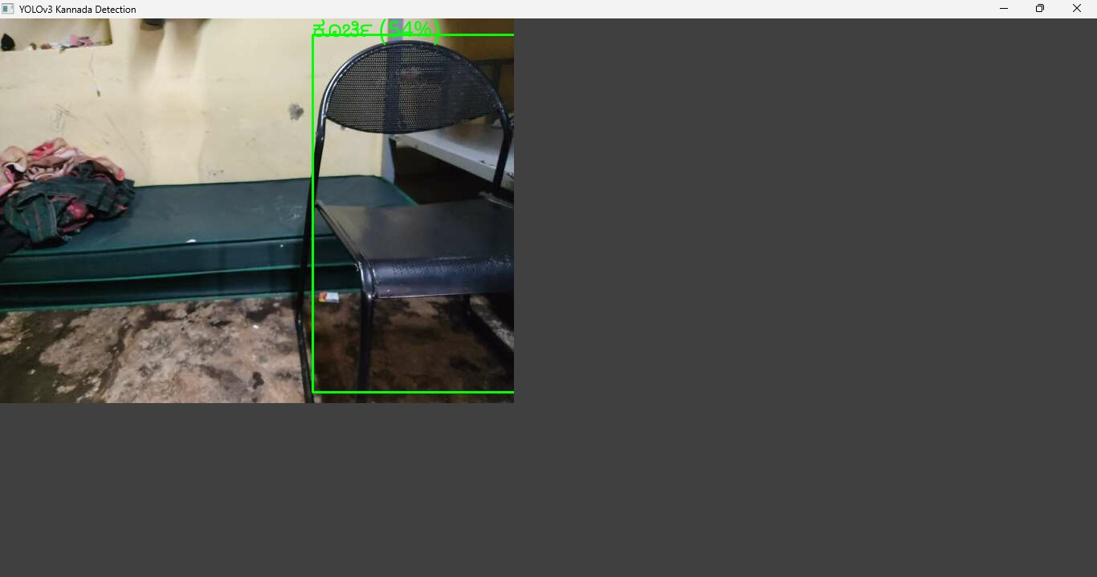
Figure.6.5. Partially Occluded Objects

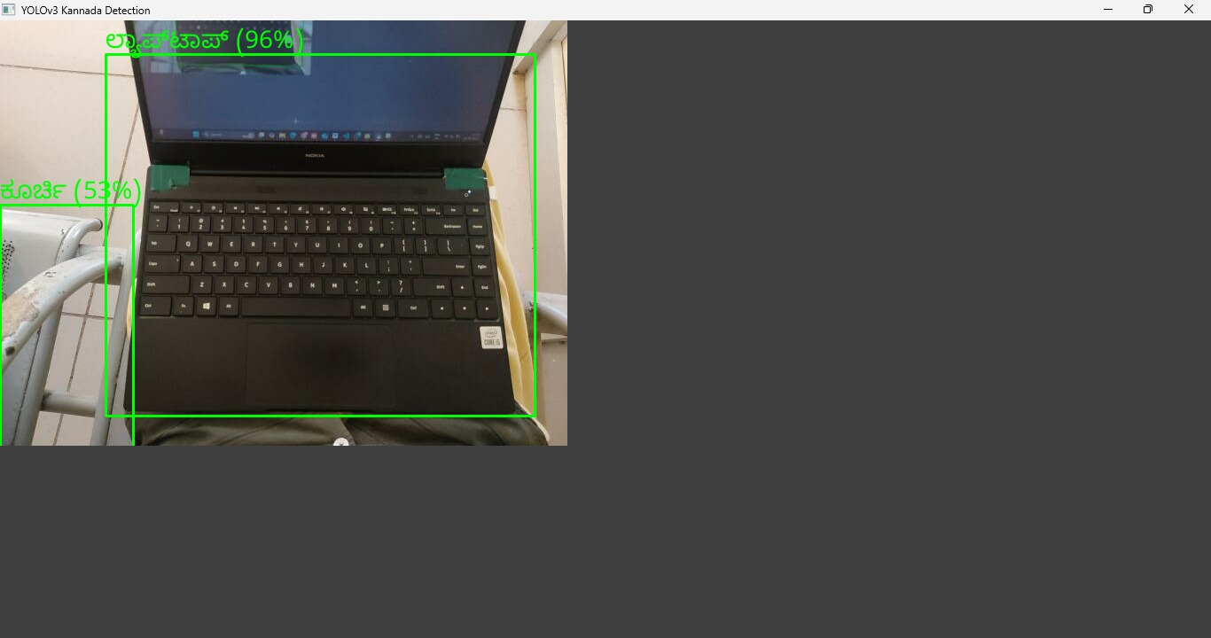
Figure.6.6.Partially Occluded Objects

This system has ability to detect partially occluded objects, in the above image the object is appearing to the frame by half of its shape but the system detects perfectly of original object.

CONCLUSION

An object detection system identifies and locates real-world objects from a digital image, where objects can belong to any category, including humans, cars, vehicles, etc. This project uses OpenCV and the YOLO algorithm to enable real-time object detection.
The system has been developed in Python, using machine learning techniques, and is particularly tailored for applications such as assistive technology for the visually impaired. Unlike the original setup, the final output in this project is enhanced by providing object labels and audio feedback in the Kannada language, spoken in the developer’s own voice. This personalized regional language support makes the system more accessible and practical for users in Karnataka or Kannada-speaking regions.
By identifying objects and announcing them in Kannada through earphones or a speaker, the system helps blind users navigate their environment more confidently and safely. This contributes to increased independence and improves the quality of life.
Overall, the project demonstrates a real-time vision assistance system for blind individuals, utilizing computer vision and machine learning to convert visual inputs into audible Kannada speech—in the developer’s own voice—offering a region-specific, personalized, and inclusive solution for the visually impaired.

BIBLIOGRAPHY

[1]. Everingaham, L. Van Gool, C. K. Williams, J. Winn, and A. Zisserman. The pascal visual object classes (voc) challenge.
[2]. C.-Y. Fu, W. Liu, A. Ranga, A. Tyagi, and A. C. Berg. Dssd: Deconvolutional single shot detector
[3]. D. Gordon, A. Kembhavi, M. Rastegari, J. Redmon, D. Fox,and A. Farhadi. Iqa: Visual question answering in interactive environments.
[4]. K. He, X. Zhang, S. Ren, and J. Sun. Deep residual learning for image recognition.
[5]. J. Huang, V. Rathod, C. Sun, M. Zhu, A. Korattikara, A. Fathi, I. Fischer, Z. Wojna, Y. Song, Guadarrama, et al. Speed/accuracy trade-offs for modern convolutional object detectors.
[6]. Girshick R, Donahue J, Darrell T, Malik J. Rich feature hierarchies for accurate object detection and semantic segmentation. In Proceedings of the IEEE Conference on Computer Vision and Pattern Recognition.
[7]. Dong J, Li H, Guo T, Gao Y. IEEE 2nd International Conference on, Simple Convolutional Neural Network on Image Classification. Conf. Using Big Data. 10.1109/ICBDA.2017. 8078730, p. 721–724 in ICBDA.
[8]. Ren S, He K, Girshick R, Sun J, Faster r-cnn: Towards real-time object detection with region proposal networks. In Advances in Neural Information Processing Systems. V.
[9]. Jeong J, Park H, Kwak N. Enhancement of SSD by concatenating feature maps for object detection. S. Chandel, "Learn Open CV," [Online]. https://www.learnopencv.com/selective-search-forobjectdetection-cpp-python/. Available:
[10]. Khan, M. J., Zafar, A., Tumanian, V., Yue, D., & Li, G. (2019, November). Object Detection Boosting using Object Attributes in Detect and Describe Framework. In 2019 IEEE 31st International Conference on Tools with Artificial Intelligence (ICTAI) (pp. 886-893). IEEE.

